CS 161
Assignment 3
Simultaneous Equation Solver

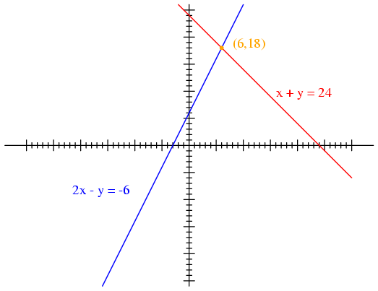

Assignment:

Write a program in C++ to solve a pair of simultaneous linear equations in two variables x and y.

If the equations are written:

a ₁ x + b ₁ y = c ₁
a ₂ x + b ₂ y = c ₂

The solutions are (by Cramer’s rule)

x = ( c ₁ b ₂ - c ₂ b ₁ ) / ( a ₁ b ₂ - a ₂ b ₁ )
y = ( a ₁ c ₂ - a ₂ c ₁ ) / ( a ₁ b ₂ - a ₂ b ₁ )

First Sample Dialog

Welcome to Nick’s Simultaneous Equation Solver.
Please enter a1, b1, c1 (separated by spaces): 1 1 24
Please enter a2, b2, c2 (separated by spaces): 2 -1 -6
The solution of the equations:
1x + 1y = 24
2x + -1y = -6
is x = 6.00 and y = 18.00
Thank you for using Nick’s Simultaneous Equation Solver.

Second Sample Dialog

Welcome to Nick’s Simultaneous Equation Solver.
Please enter a1, b1, c1 (separated by spaces): 1 2 2
Please enter a2, b2, c2 (separated by spaces): 1 -2 -12
The solution of the equations:
1x + 2y = 2
1x + -2y = -12
is x = -5.00 and y = 3.50
Thank you for using Nick’s Simultaneous Equation Solver.

Design Considerations

Your program should follow the example dialog above except that the name Nick should be replaced with your name. The text in red bold is that which is input by the user. The rest is output by your program. Of course, the results should be calculated by your program depending on what data the user inputs.

You should assume the numeric input from the user is always an integer (as shown in the example), so you should use variables of type ‘int’ for these.

However, the results (solution) may well not be integer, so you will need to use variables of type ‘double’ for these. You should format your output to display the solution to exactly two places of decimals (as shown in the example).

Deliverables:

Please upload your program source code (.cpp file) as usual. Be sure to comment your code as required, and to acknowledge any sources of help you may have received. Your header comments should include the identification of the assignment and your name. It should also include a comment indicating any sources of help you may have received. If there were none, the line should read:

// Sources: None.

Note:

I think this is not a totally straightforward project, especially so early in the term. For example, what will happen if the lines are parallel? How should the program handle this situation? Although I will be discussing this in class, the actual implementation will be difficult for some. Please utilize your classmates to help you if you do not fully understand the presentation in class. The discussion board is your friend… please use it!

